**Experiment 3**

**Aim-**

1. Create a simple HTML “Hello World” Project using AngularJS Framework and apply ng-controller, ng-model and expressions.
2. Create an application like Students Record using AngularJS.

**Theory-**

AngularJS is a JavaScript framework written in JavaScript.

AngularJS is distributed as a JavaScript file, and can be added to a web page with a script tag:

<script src="https://ajax.googleapis.com/ajax/libs/angularjs/1.6.9/angular.min.js"></script>

AngularJS extends HTML with ng-directives.

The ng-app directive defines an AngularJS application.

The ng-model directive binds the value of HTML controls (input, select, textarea) to application data.

The ng-bind directive binds application data to the HTML view.

<!DOCTYPE html>

<html>

<script src="https://ajax.googleapis.com/ajax/libs/angularjs/1.6.9/angular.min.js"></script>

<body>

<div ng-app="">

<p>Name: <input type="text" ng-model="name"></p>

<p ng-bind="name"></p>

</div>

</body>

</html>

AngularJS starts automatically when the web page has loaded.

The ng-app directive tells AngularJS that the <div> element is the "owner" of an AngularJS application.

The ng-model directive binds the value of the input field to the application variable name.

The ng-bind directive binds the content of the <p> element to the application variable name.

**Output-**

1. Create a simple HTML “Hello World” Project using AngularJS Framework and apply ng-controller, ng-model and expressions.

<!DOCTYPE html>

<html lang="en">

<head>

<meta charset="UTF-8">

<meta http-equiv="X-UA-Compatible" content="IE=edge">

<meta name="viewport" content="width=device-width, initial-scale=1.0">

<title>Hello</title>

<script src="https://ajax.googleapis.com/ajax/libs/angularjs/1.6.9/angular.min.js"></script>

</head>

<body >

<div ng-app="" >

First Name:<input type="text" ng-model="fname">

<!-- Last Name:<input type="text" ng-model="lname"> -->

<h1>Hello {{fname}} </h1>

</div>

</body>

</html>

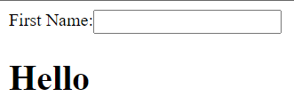

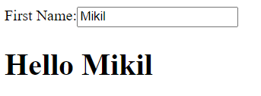

Create an application like Students Record using AngularJS.

<!DOCTYPE html>

<html lang="en-US">

<script src="https://ajax.googleapis.com/ajax/libs/angularjs/1.6.9/angular.min.js"></script>

<body>

<h1 style="display: flex; justify-content: center; margin-top: 100px;"><u>Student Details</u></h1>

<div ng-app="checkboxApp" style="display: flex; justify-content: center;" ng-controller="checkboxCtrl">

<form name="myForm">

<table>

<tr>

<td>First Name:</td>

<td><input type="text" name="fname" ng-model="fname" required>

<span style="color:red" ng-show="myForm.fname.$touched && myForm.fname.$invalid">First name is

required.</span>

</td>

</tr>

<tr>

<td>Last Name:</td>

<td><input type="text" required name="lname" ng-model="lname" ng-minlength="3">

<span style="color:red"

ng-show="myForm.lname.$touched && (myForm.lname.$invalid || myForm.lname.$error.minlength)">Minimum

3 characters required.</span>

</td>

</tr>

<tr>

<td>Email:</td>

<td><input type="email" name="emailID" ng-model="emailID"

ng-pattern="/^[a-z]+[a-z0-9._-]*@[a-z]+\.[a-z.]{2,5}$/" required>

<span style="color:red" ng-show="myForm.emailID.$error.pattern">Enter valid email.</span>

</td>

</tr>

<tr>

<td>Date of Birth:</td>

<td><input type="date" ng-model="dob"></td>

</tr>

<tr>

<td>Gender:</td>

<td>

<select ng-model="gender" name="gender" required>

<option value="Male" >Male</option>

<option value="Female">Female</option>

</select>

<span style="color:red" ng-show="myForm.gender.$touched && myForm.gender.$invalid">Select your gender.</span>

</td>

</tr>

<tr>

<td>Training Type:</td>

<td><input type="radio" name="radio1">Online</td>

</tr>

<tr>

<td>

<td><input type="radio" name="radio1">Offline</td>

</td>

</tr>

<tr>

<td>Subject:</td>

<td>

<table>

<tr>

<td><input type="checkbox" ng-model="chkselct.sub1">AI&DS-1</td>

</tr>

<tr>

<td><input type="checkbox" ng-model="chkselct.sub2">Web X.0</td>

</tr>

<tr>

<td><input type="checkbox" ng-model="chkselct.sub3">DMBI</td>

</tr>

<tr>

<td><input type="checkbox" ng-model="chkselct.sub4">WT</td>

</tr>

<tr>

<td><input type="checkbox" ng-model="chkselct.sub5">EH&F</td>

</tr>

</table>

</td>

</tr>

<tr>

<td colspan="2">

<span style="color:red;" ng-show="validationmsg">Please select at least one

Checkbox</span><br>

<input type="submit" value="Submit" ng-click="checkvalidation();" onclick="" />

</td>

</tr>

<tr>

<td>

</td>

</tr>

</table>

<b>First Name:</b> {{fname}} <br />

<b>Last Name:</b> {{lname}} <br />

<b>Roll No:</b> {{emailID}} <br />

<b>Date of Birth:</b> {{dob}} <br />

<b>Gender:</b> {{gender}} <br />

</form>

</div>

<script>

var app = angular.module('checkboxApp', []);

app.controller('checkboxCtrl', function ($scope) {

$scope.validationmsg = false;

$scope.checkvalidation = function () {

var chkselct = $scope.chkselct;

if (chkselct == false || chkselct == undefined)

$scope.validationmsg = true;

else

{$scope.validationmsg = false;

alert('Form successfully submitted!');}

}

});

</script>

</body>

</html>

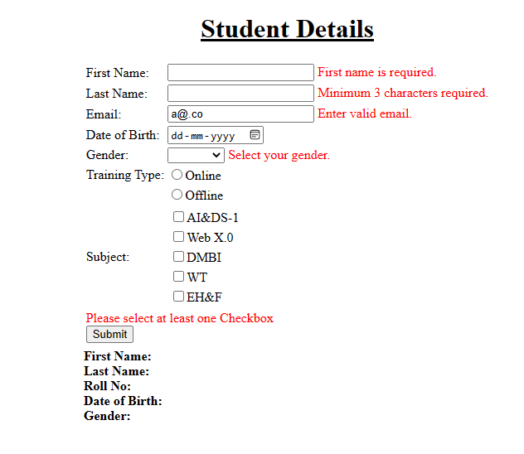

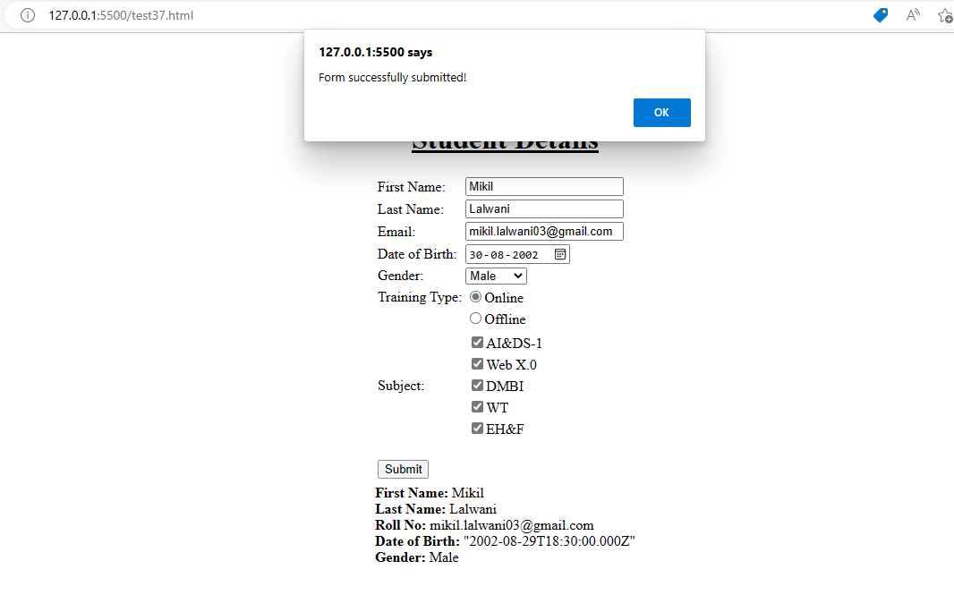

**Conclusion-**

We successfully used AngularJs to create a form and validated it using directives and controllers in AngularJs.